DNS with MX Records – Email Routing

🌐 What Is DNS with MX Records – Email Routing?
# Source: Chatgpt (GPT-5-Mini) at [1/21/2026]
DNS with MX Records is how the internet knows which server should receive email for a domain.
It’s a critical part of email routing — making sure that messages sent to addresses like user@example.com reach the correct mail server for example.com.

🧠 What’s Happening Behind the Scenes?
# Source: Chatgpt (GPT-5-Mini) at [1/21/2026]
When someone sends an email to you@yourdomain.com, the sending server asks the DNS (Domain Name System):
"Hey DNS, where do I send mail for yourdomain.com?"
The DNS responds with an MX record — a special type of DNS entry that tells it which mail server handles email for that domain.

📦 What Is an MX Record?
# Source: Chatgpt (GPT-5-Mini) at [1/21/2026]
MX = Mail Exchanger
An MX record in DNS tells other mail servers:
- The hostname of your mail server
- The priority of that server (if multiple)

📄 Example MX Record
# Source: Chatgpt (GPT-5-Mini) at [1/21/2026]
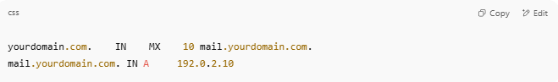
yourdomain.com. IN MX 10 mail.yourdomain.com.
mail.yourdomain.com. IN A 192.0.2.10

- MX → Type of record
- 10 → Priority (lower = higher priority)
- mail.yourdomain.com → Hostname of your mail server

🔁 Example Flow: Sending an Email
# Source: Chatgpt (GPT-5-Mini) at [1/21/2026]
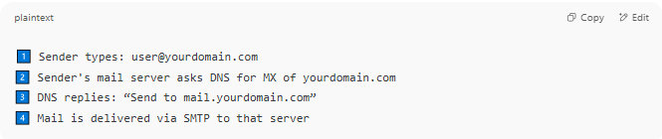

1️⃣ Sender types: user@yourdomain.com
2️⃣ Sender's mail server asks DNS for MX of yourdomain.com
3️⃣ DNS replies: “Send to mail.yourdomain.com”
4️⃣ Mail is delivered via SMTP to that server

🧰 Real-World Example
# Source: Chatgpt (GPT-5-Mini) at [1/21/2026]
To see a domain’s MX records:
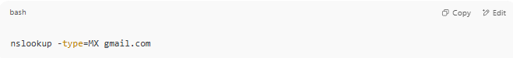
nslookup -type=MX gmail.com

You’ll see something like:
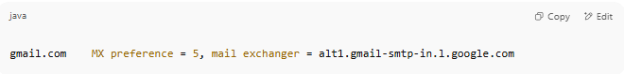
gmail.com MX preference = 5, mail exchanger = alt1.gmail-smtp-in.l.google.com

🎯 Why MX Records Matter
# Source: Chatgpt (GPT-5-Mini) at [1/21/2026]
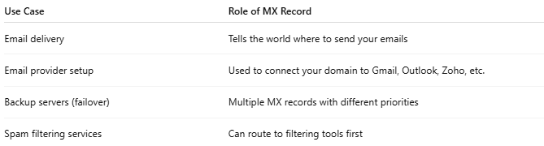

Use Case | Role of MX Record
Email delivery | Tells the world where to send your emails
Email provider setup | Used to connect your domain to Gmail, Outlook, Zoho, etc.
Backup servers (failover) | Multiple MX records with different priorities
Spam filtering services | Can route to filtering tools first

✅ Summary
# Source: Chatgpt (GPT-5-Mini) at [1/21/2026]
MX (Mail Exchanger) records in DNS are essential for routing email to the correct mail server for a domain.
Without properly configured MX records, your domain cannot receive email.

